Applications:

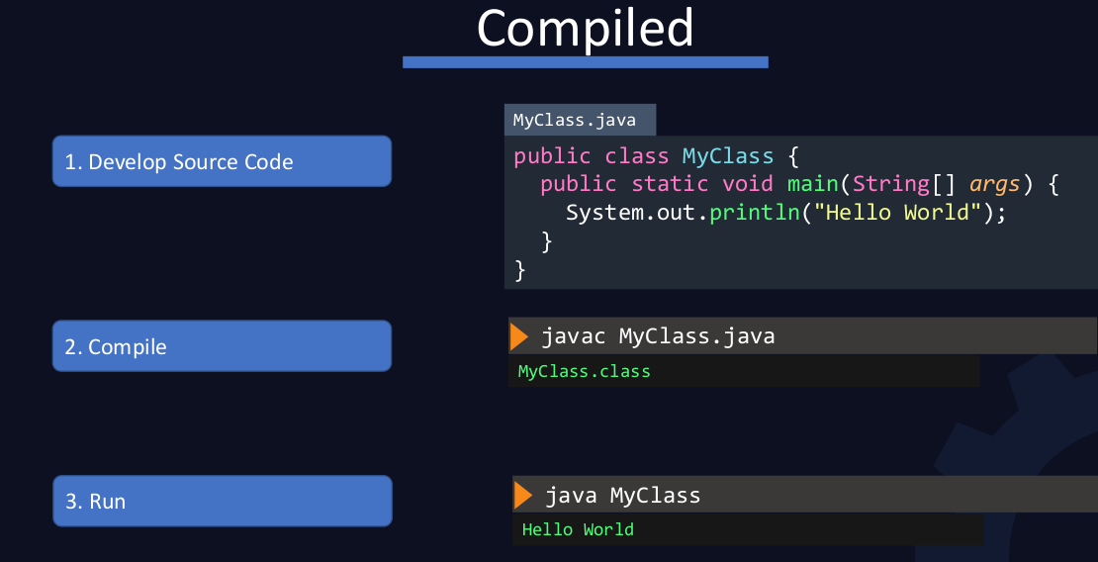

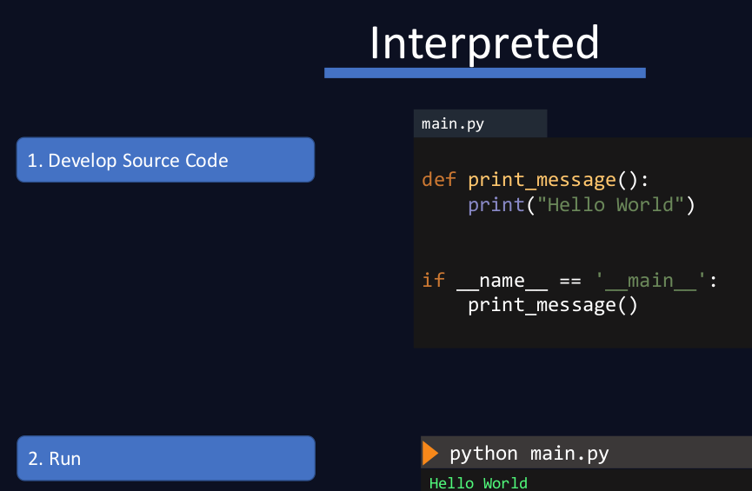

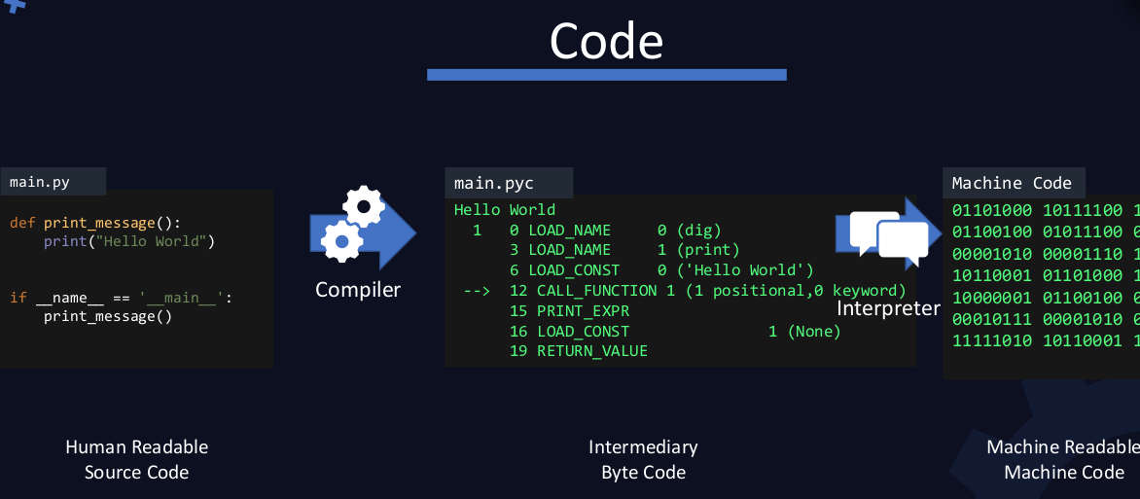

java Building and packaging:

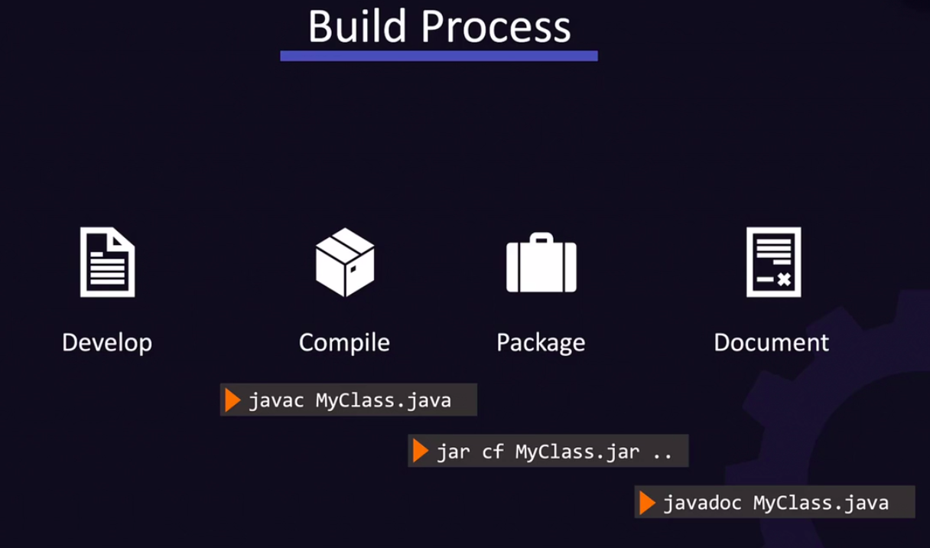

document:
cd /opt/app/;
javadoc -d doc MyClass.java

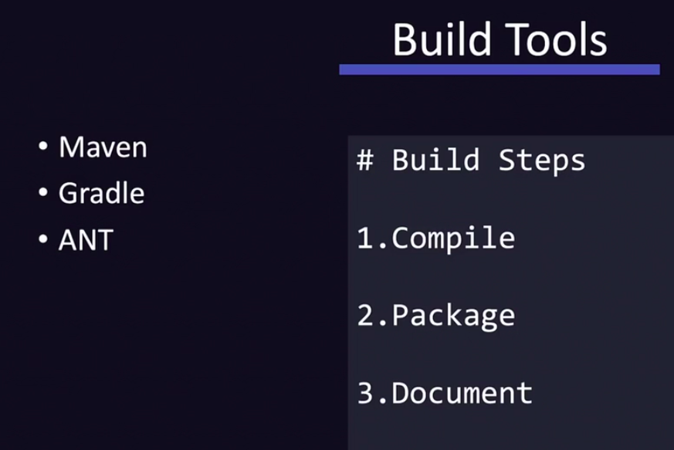

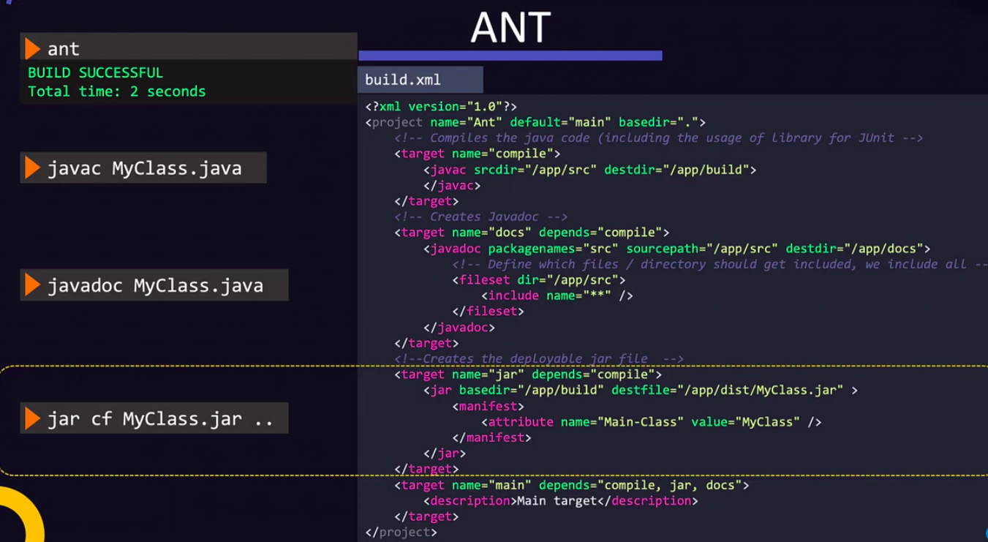
installation: sudo yum install -y ant
compile: ant compile jar

Node js:
Node js version= node -v ,
Node js Run : node FileName.js

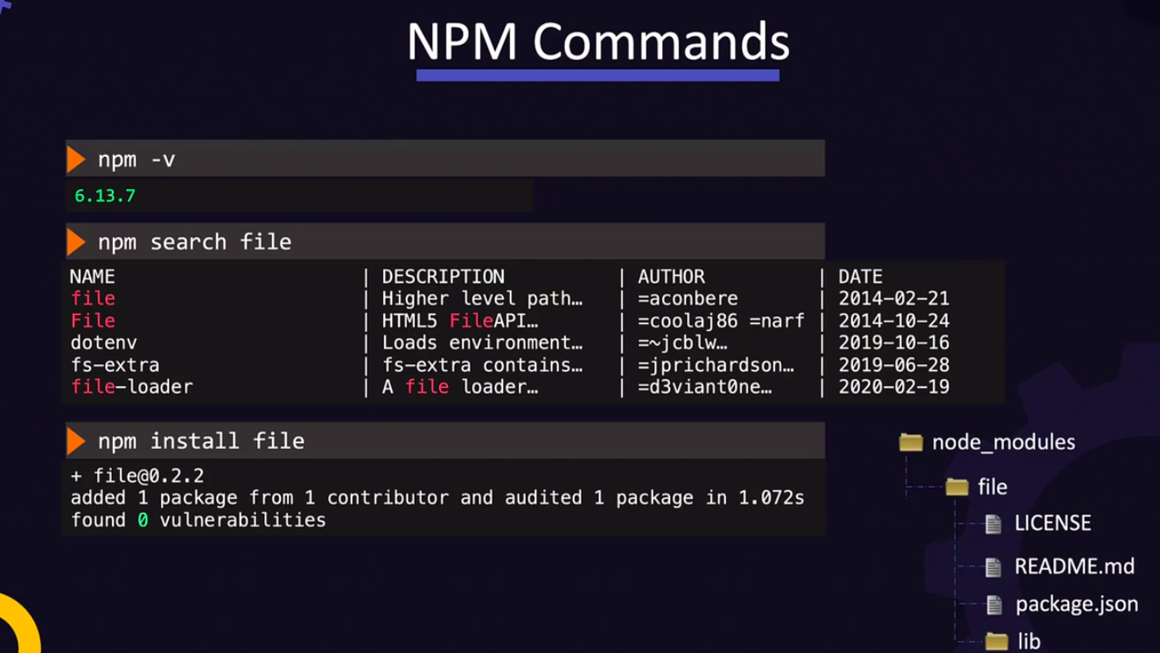

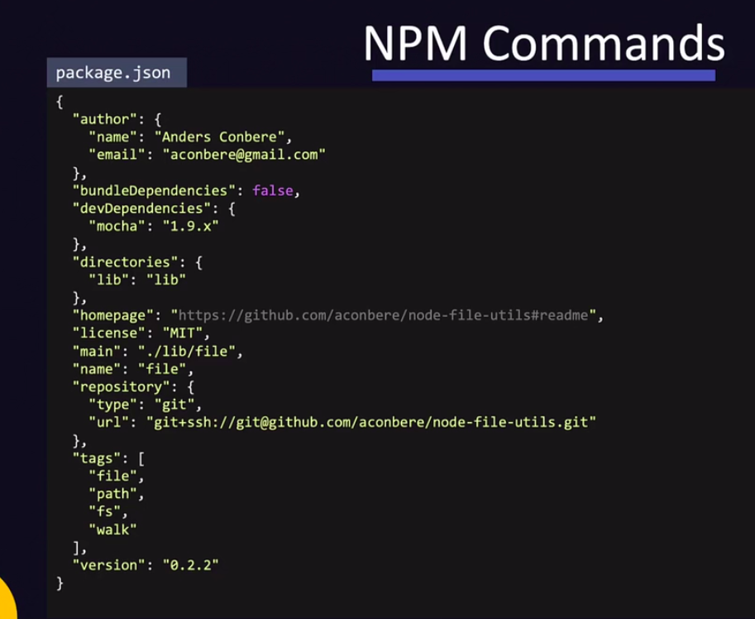

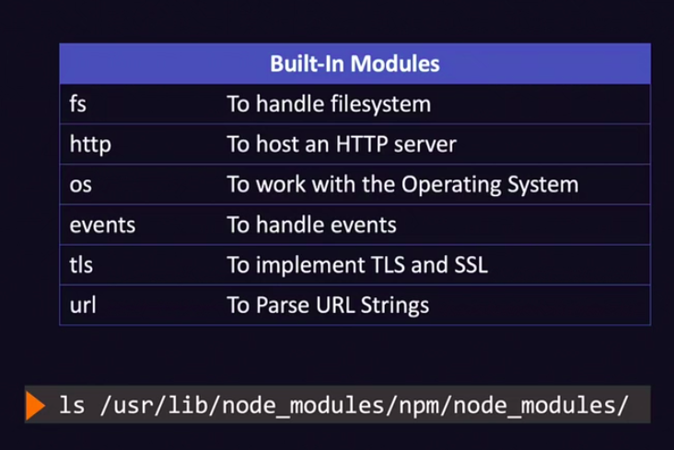
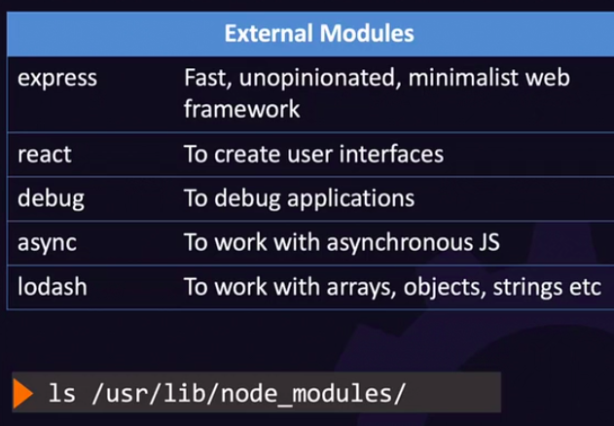

python: python3 -V
pip=> pip -V

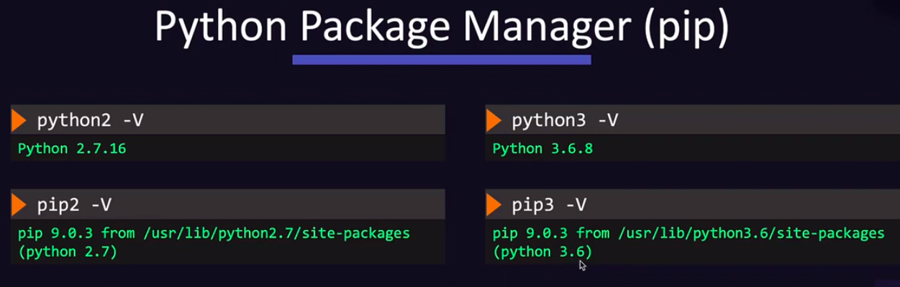

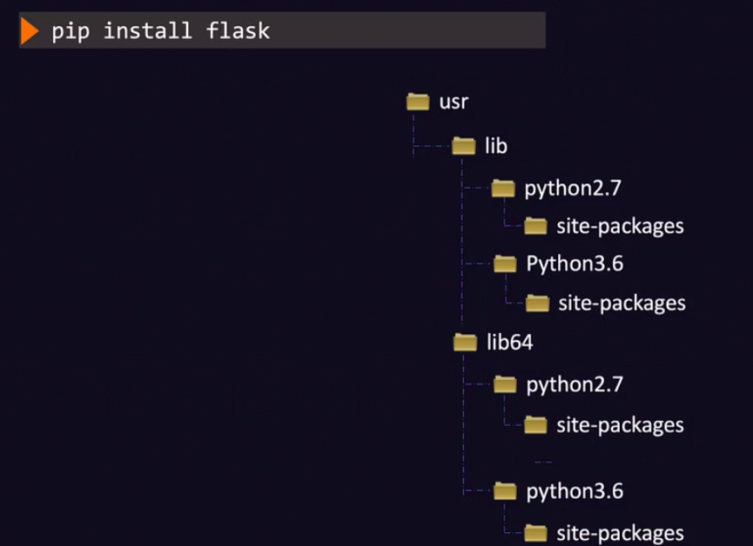

Location of package installed => pip show packageName(Flask)

pip install -r requriments.txt => to install all the packages in requriemnts file.

To Upgrade => pip install PackageName –upgrade.

To uninstall => pip uninstall PackageName.

Source Control Management:

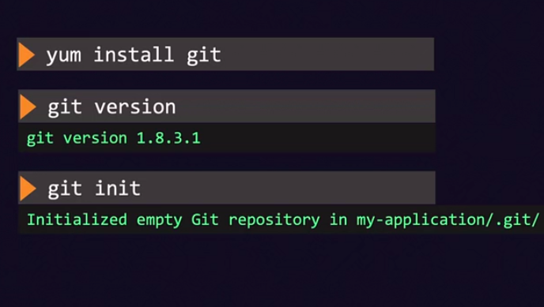

Web server:

static webpages or standalone applications:

Dynamic web server:

Apache web server:

sudo yum install -y httpd;
sudo service httpd start

sudo service httpd status

Apache Tomcat: used to host for java based Applications.
Default port no: 8080.

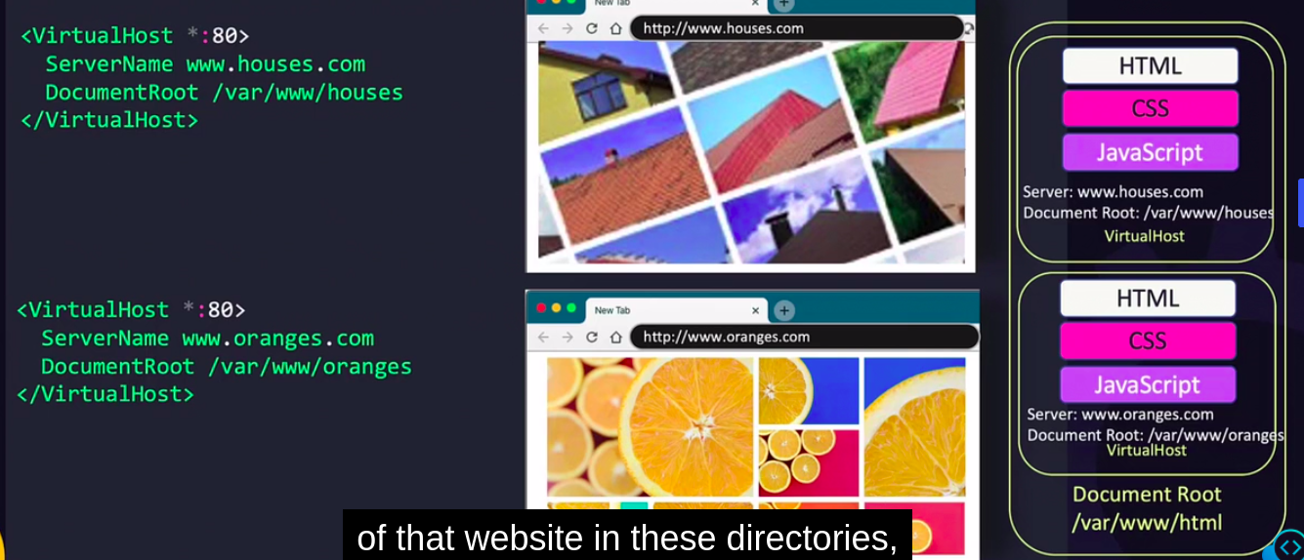

Python Flask:
default port no: 5000

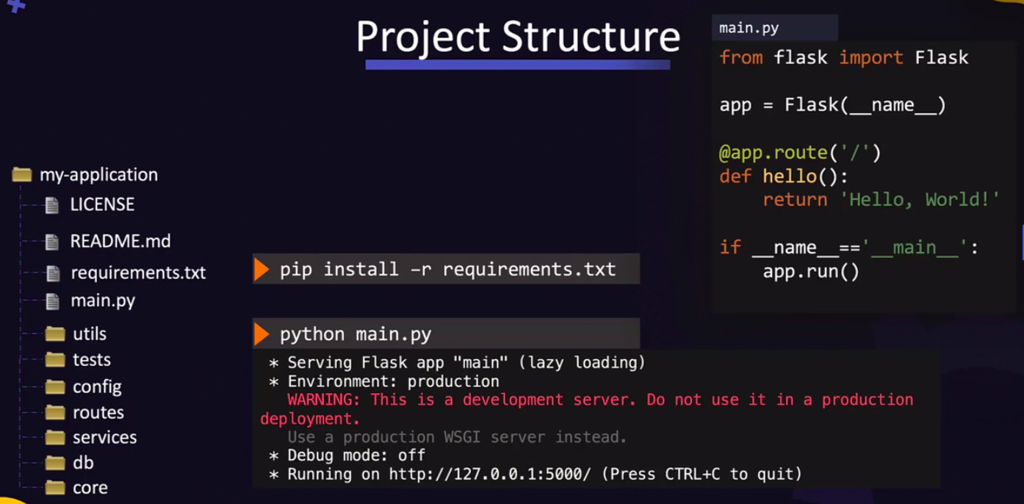

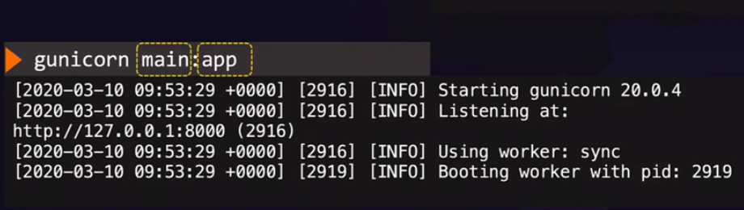
Gunicorn
default port no:8000

Express Js (NODE):
port No: 3000

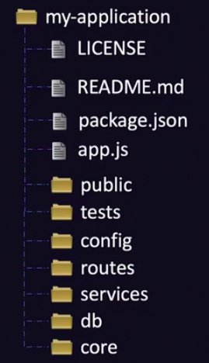
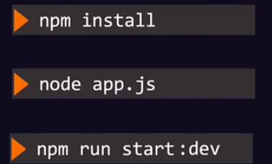

IP Address and Port:

ports: 65535 ports are avaialble to communicate when they have a request.
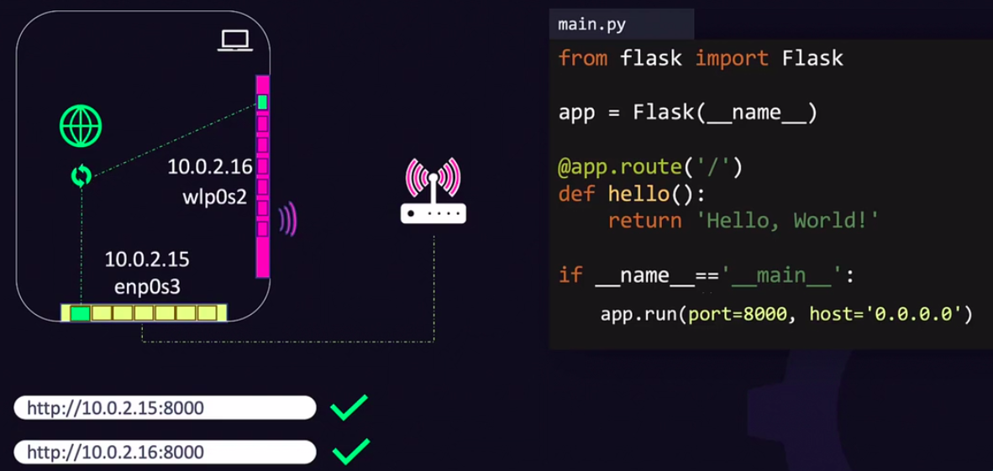

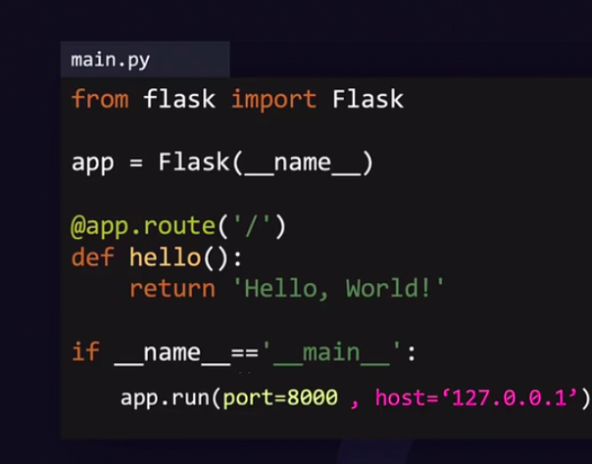

Database:

SQL:
Sql=> Store the data in tables in(rows, colums) indexs.
Dis-advantage is = in sql it may lead to a situation of Empty cells.
Eg: Mysql , postgre Sql, ms sql server.
MYSQL:
Creating user:

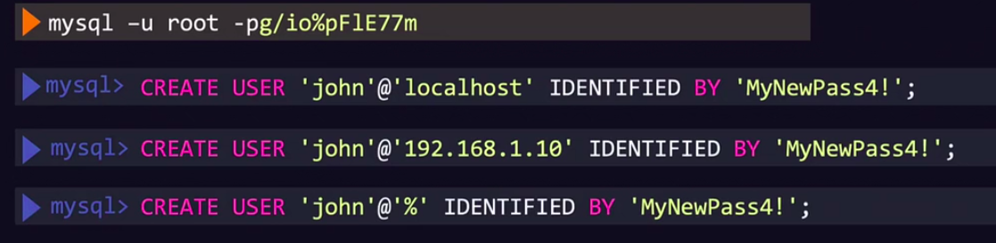
Previleges:

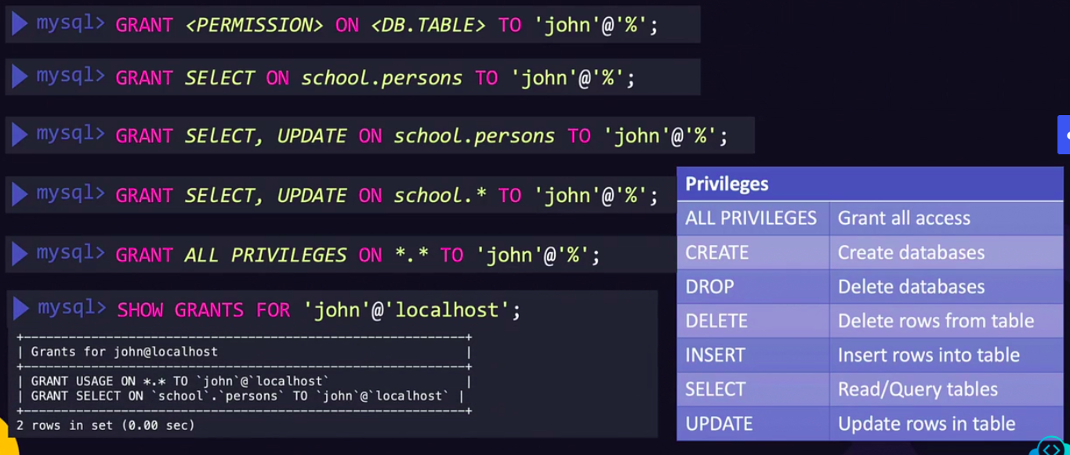

NOSQL:

NoSql => store the data in from of document each individual get a document a and stored in the file , these files can be in any formate or structure and changes of one files does not effect other files.
JSON representation of NOSQL documents.
In Nosql each row get the document allocated. All documents cgrouped together and called collection and multiple collections together called Database.
Eg: mongoDB , DynamoDB,

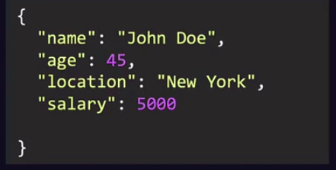

MongoDB:

install=> yum install mongodb-org
systemctl start mongo
systemctl status mongo
log files => cat varlog/mongodb/mongod.log
configuration files => /etc/mongod.conf

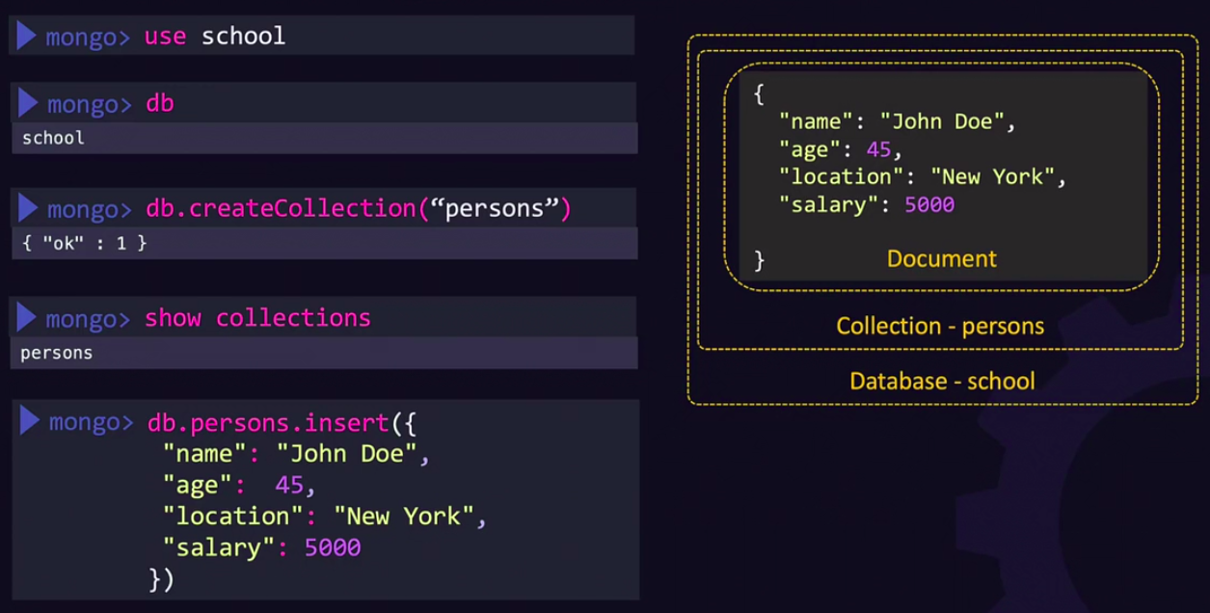

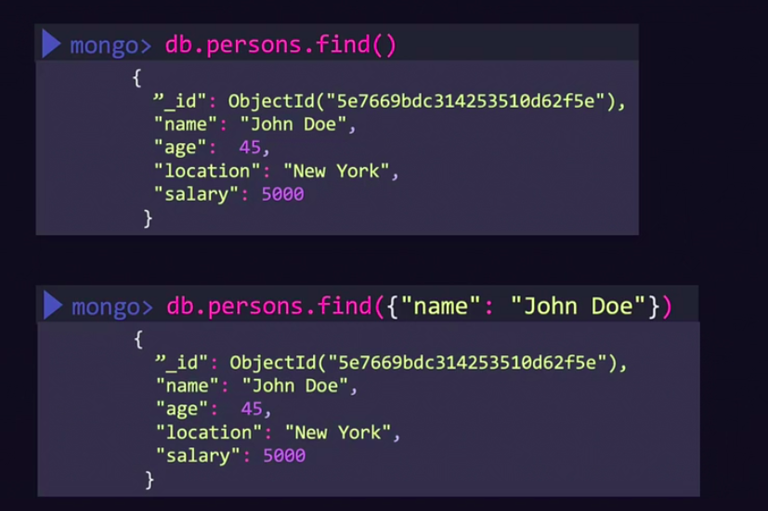

Certificate:
A certificate is used to guarantee trust between two parties during a transaction.

SSL And TLS:
SSL stands for Secure Socket Layer while TLS stands for Transport Layer Security. Both Secure Socket Layer and Transport Layer Security are the protocols used to provide security between web browsers and web servers.

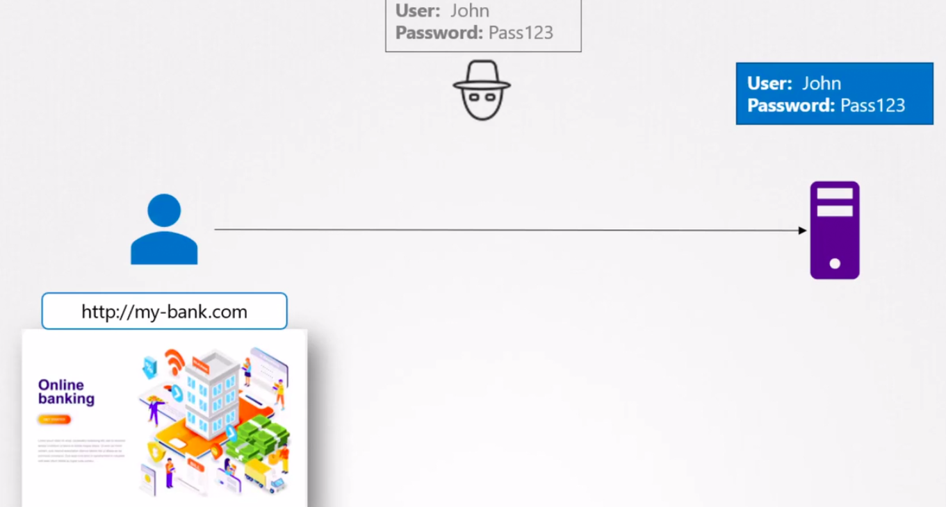

Symentric Encryption:Symmetric encryption uses a single key to encrypt and decrypt.

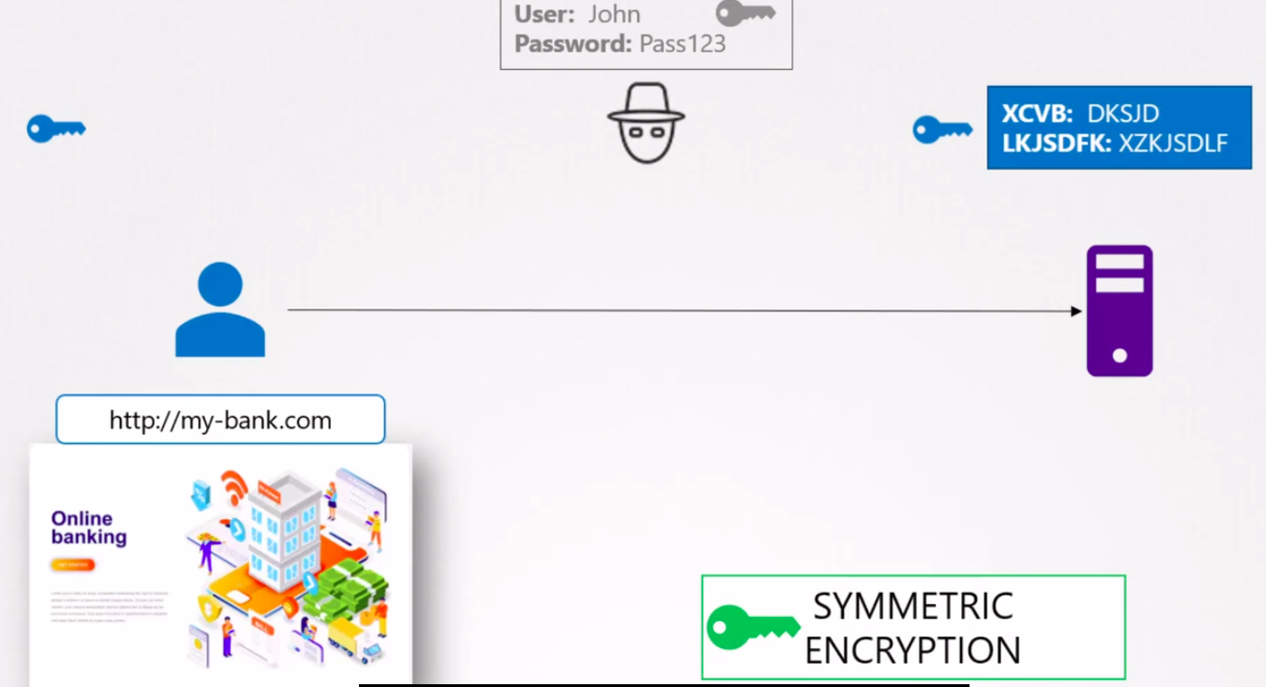

ASymentric Encryption:
Asymmetric encryption uses a mathematically related pair of keys for encryption and decryption: a public key and a private key. If the public key is used for encryption, then the related private key is used for decryption.

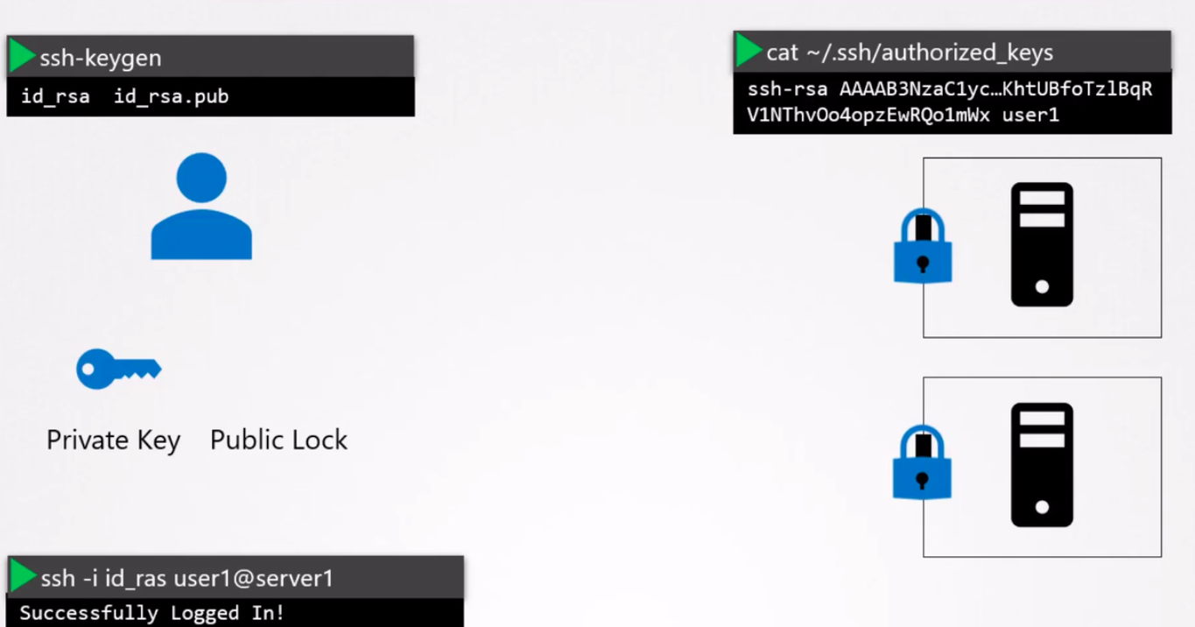

SSH=> Secure Socket Shell.

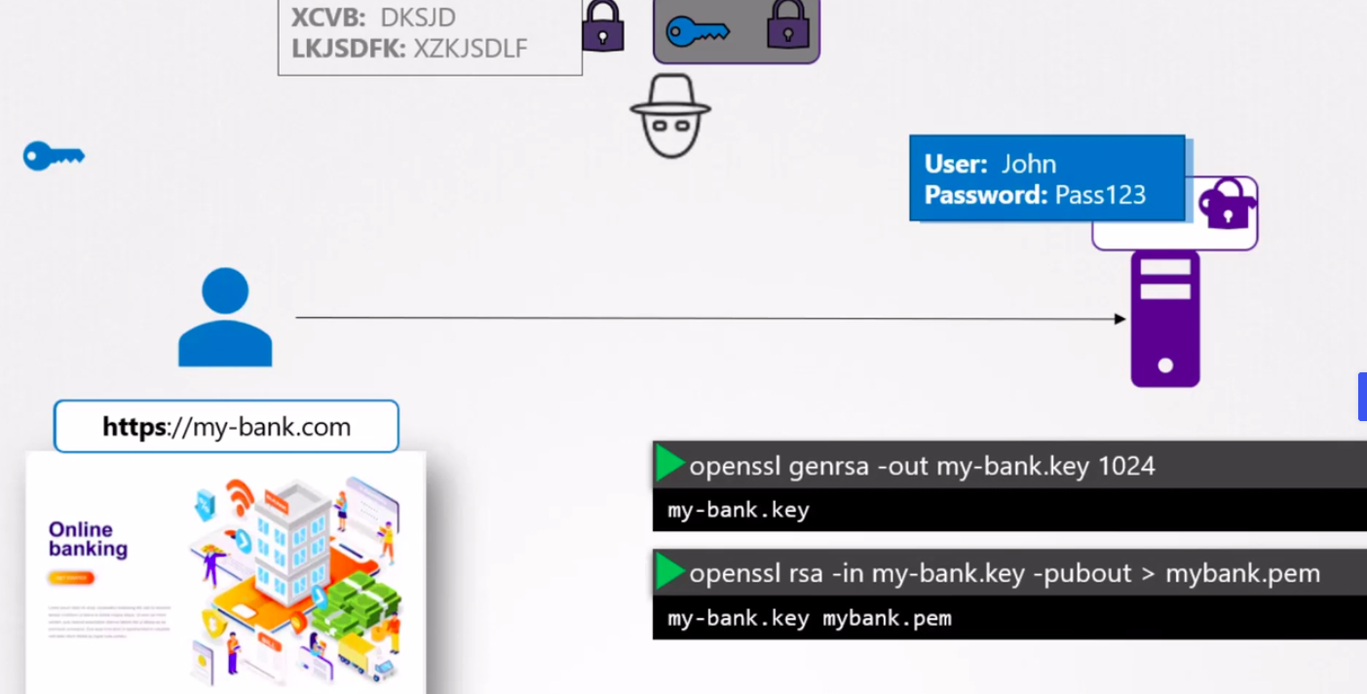

YAML:

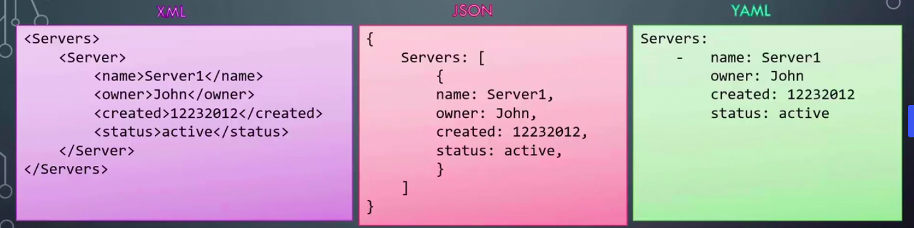

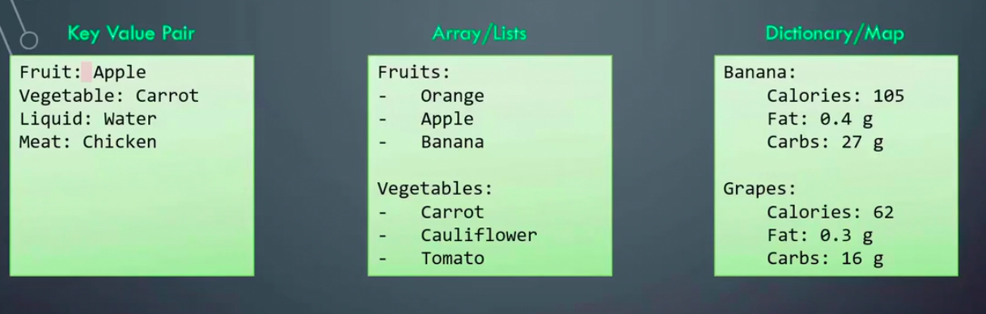
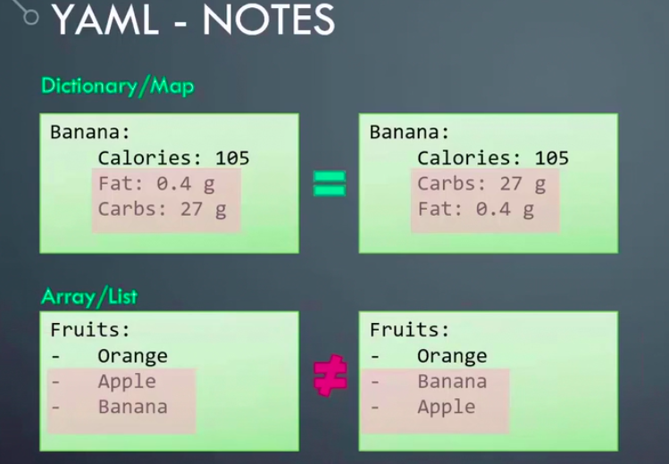
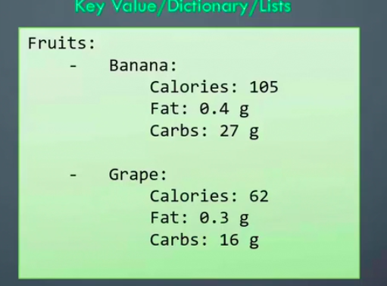

JSON PATH:



